6. Application and evaluation of simulations

3.24 Urban Environments

Notes:

* Show how it is used in practice
* What software is there
  + SoundPlan
  + CandaA
* Get urban environment geometrical data from Public sources
* People should get an overview what they can do with it, what is input output of this workflow
* Accoring to mvo in “Lärm” (Noise) Exam for civil engineers there is an Exercise with SOUNDPlan, but I couldn’t find it.
* Stop with soundmaps

<https://www.datakustik.com/fileadmin/user_upload/CadnaA/Software_Screenshots/Short_feature_videos/Map_3D_Moving_Car_01.mp4>

The video shows an animated noise map of a single car passing by the road. The following automated sequence of tasks is performed to generate the animated noise map: calculation at one position, opening of the 3D view, saving the picture frame, moving the source to the next position.

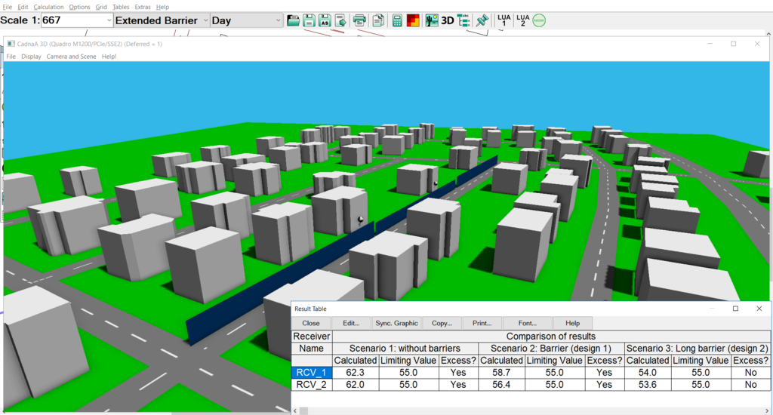

The result table shows the results of the calculation for three different scenarios (without noise barrier and with two different barrier designs). The effectiveness of both designs are compared with regards to the limiting noise value and shown in the table.

https://www.datakustik.com/noise-outdoors/

**Noise Outdoors**

We are proud to develop the most powerful software for the calculation, assessment and presentation of outdoor noise. Our software solutions for the calculation and assessment, prediction and presentation of environmental noise exposure are powerful, yet easy to use. Whether your objective is to study the noise immission of an industrial plant, of a commercial center including a parking lot, of a new road or railway scheme or even of entire towns and urbanized areas: **CadnaA** is designed to handle all these tasks.

[](https://www.datakustik.com/noise-outdoors/industry-noise/)

**Industry Noise**

**CadnaA** is widely used to predict the noise impact at the vicinity caused by industrial plants and their future modifications. It is successfully applied to the simulation of the environmental impact of wind farms, commercial areas and even sport and leisure facilities.

[](https://www.datakustik.com/noise-outdoors/road-and-railway-noise/)

**Traffic Noise**

**CadnaA** is the leading software for the calculation of traffic noise. Our software is applied worldwide to existing, planned or modified roads and railway lines. In all cases, the calculation of the outdoor noise at the vicinity areas is the base of the assessment of the necessary measures, such as noise barriers or sound reduction surfaces.

[](https://www.datakustik.com/noise-outdoors/aircraft-noise/)

**Aircraft Noise**

A huge number of Airports all over the world rely on **CadnaA** for the calculation of aircraft noise. Based on the most relevant calculation methods at International level, the noise resulting from aircraft operations is determined and even combined with other types of noise.

[](https://www.datakustik.com/noise-outdoors/city-noise-mapping/)

**City Noise Mapping**

**CadnaA** has proven to be an excellent tool for the calculation of strategic noise maps of cities and even complete countries according to the **EC Directive on Environmental Noise**. Our users agree on the high calculation speed and usability as key values.

https://www.soundplan.eu/en/software/soundplannoise/

# SoundPLANnoise

## Our "all-rounder"

[](https://www.soundplan.eu/fileadmin/user_upload/soundplan-dateien/software/soundplan-noise/o-Shape-Map1.png)[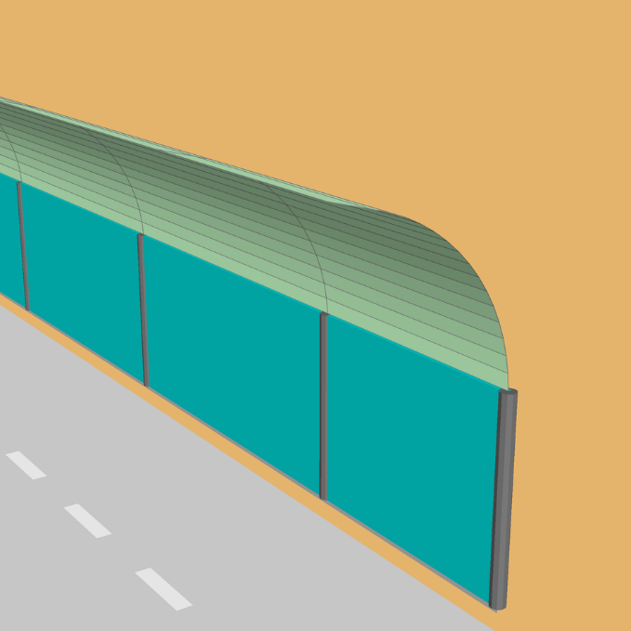](https://www.soundplan.eu/fileadmin/user_upload/soundplan-dateien/software/soundplan-noise/C-Shape-Map2.png)

#### The modular program package SoundPLANnoise

If you are in daily need of professional noise reports, you need a noise software you can rely on. Engineering offices, state and local authorities, architects, concert promoters or venues, and universities all work with our effective noise software in a wide range of application areas.

#### Professional noise surveys for all requirements

Ranging from simple standard investigations to special tasks, SoundPLANnoise offers answers to every conceivable question in the fields of noise immission control, environmental acoustics and room acoustics. This includes, for example, route planning, development plans, approval procedures, noise action plans, noise mapping, assessing open-air events or planning open-plan offices.

#### Individually adaptable - easy to use

Here's a special advantage of SoundPLANnoise: The modular structure of our software allows you quickly and easily adapt the program to your individual requirements at any time.

SoundPLANnoise is also intuitive to use. Along with its well thought-out workflow, this enables you to work efficiently - from modelling to the graphical and tabular presentation of the results - so that you can reach your goal as quickly as possible.

#### Always up to date

Our maintenance contract guarantees that your SoundPLANnoise software is always up to date, so that the calculations you perform are always based on the latest guidelines and standards.

SOUNDPlan (https://www.soundplan.eu/en/software/soundplannoise/highlights/)

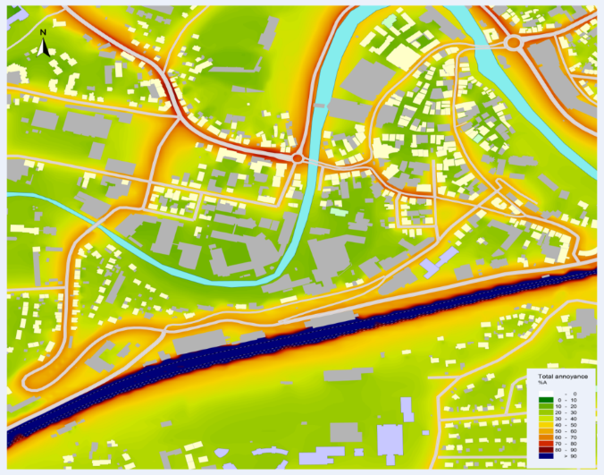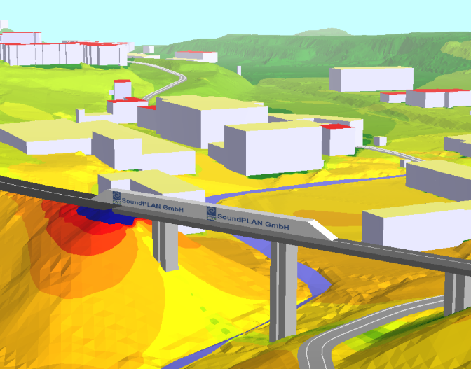

### One software for many areas of application

SoundPLANnoise includes everything from modelling, calculations and tabular documentation in various levels of detail to informative plans for road and rail noise, commercial and leisure noise, aircraft noise, and Hallin (sound propagation indoors).

### User-friendly analysis and optimization tools

In addition, SoundPLANnoise offers extensive tools - first and foremost among them is the integrated spreadsheet optimized for your problems. Further tools offer, for example, the optimization of noise protection structures, noise remediation, noise allocation, and noise protection concepts for industrial plants as well as various evaluations (such as the number of affected inhabitants) or the best cost-benefit ratio.

### Dynamic segmentation in the data model

A special feature of the two calculation modes "road" and "rail" is that even if any of the properties is modified in the course of the road or the railway (e.g. change of speed or bridge addition), there is no need to manage different road or railway segments.

### Usage of extensive system libraries

As a SoundPLANnoise user, you have access to extensive system libraries for emission spectra, sound attenuation and absorption, which are regularly updated.

**CadnaA** (Computer Aided Noise Abatement) is the leading software for the calculation, presentation, assessment and prediction of environmental noise. Whether your objective is to study the noise immission of an industrial plant, of a mart including a parking lot, of a new road or railway scheme or even of entire towns and urbanized areas: CadnaA is designed to handle all these tasks. (<https://www.datakustik.com/products/cadnaa/cadnaa/>)

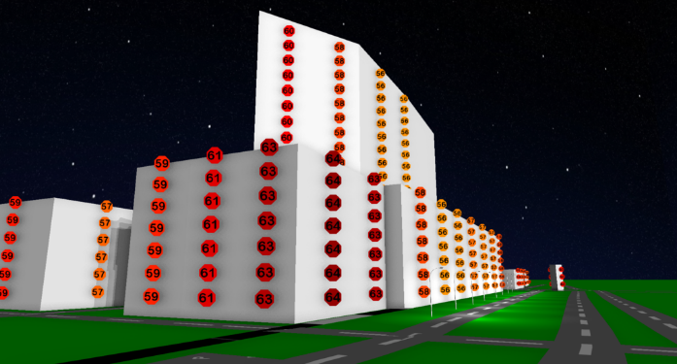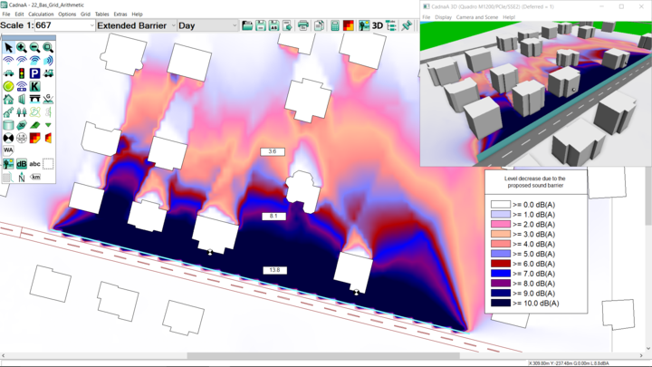

Figure: (left) building noise map at a hotel. The screenshot shows the calculated receivers on the facades. (right) Noise reduction of a proposed sound barrier. The noise map is the difference between the noise map without barrier and the map with barrier. (https://www.datakustik.com/products/cadnaa/features/analysis-and-postprocessing/)